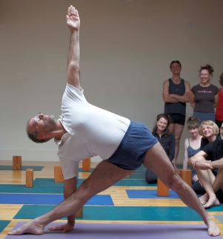
SPECIAL EVENING 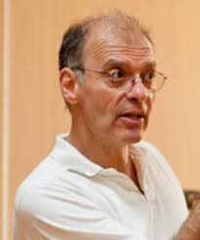
WITH MANOUSO MANOS
November 12, 2018
6:00-8:00pm

Manouso Manos is one of the most skilled and experienced of the Senior Iyengar Yoga Teachers. He holds one of only two Advanced Senior certificates granted worldwide by B.K.S. Iyengar. He began his studies with Sri B.K.S. Iyengar in 1976. After numerous trips to Pune, India, and over three decades of personal practice, his understanding, and insights into Iyengar yoga are conveyed with authenticity and precision. Methodical in his teaching, Manouso lays a solid foundation and progressively refines each of the asanas. His sense of humor and sensitivity shine through as his dynamic and challenging teaching style moves his students beyond their perceived limits. Join us for this very special class.

. . . . . . . . . . . . . . . . . . . . . . . . . . . . . . . . . . . . . . . . . . . . . . . . . . . . . . . . . . . . . . . . . . .

Registration Form

NAME __________________________________________ PHONE ______________________________________

ADDRESS _____________________________________________________________________________________

CITY,STATE_________________________________________________ ZIP_______________________________

EMAIL________________________________________________________________________________________

